**WEEK-3 CODING**

1.A triangle can be classified based on the lengths of its sides as equilateral, isosceles or scalene. All three sides of an equilateral triangle

have the same length. An isosceles triangle has two sides that are the same length, and a third side that is a different length. If all of the

sides have different lengths then the triangle is scalene.

Write a program that reads the lengths of the three sides of a triangle from the user. Then display a message that states the triangle’s type.

Sample Input 1

60

60

60

Sample Output 1

That's a equilateral triangle

Sample Input 2

40

40

80

Sample Output 2

That's a isosceles triangle

Sample Input 3

50

60

70

Sample Output 3

That's a scalene triangle

**PROGRAM:**

s1=int(input())

s2=int(input())

s3=int(input())

if(s1==s2==s3):

print("That's a equilateral triangle")

elif(s1==s2!=s3):

print("That's a isosceles triangle")

else:

print("That's a scalene triangle")

**OUTPUT:**

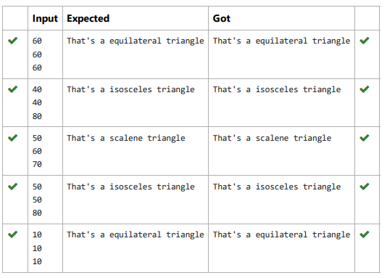

2. Write a program to calculate and print the Electricity bill where the unit consumed by the user is given from test case. It prints the total

amount the customer has to pay. The charge are as follows:

Unit Charge / Unit

Upto 199 @1.20

200 and above but less than 400 @1.50

400 and above but less than 600 @1.80

600 and above @2.00

If bill exceeds Rs.400 then a surcharge of 15% will be charged and the minimum bill should be of Rs.100/-

Sample Test Cases

Test Case 1

Input

50

Output

100.00

Test Case 2

Input

300

Output

517.50

**PROGRAM:**

u=float(input())

if u<=199:

c=u*1.20

elif u<=399:

c=u*1.50

elif u<=599:

c=u*1.80

else:

c=u*2.00

if(c>400):

s=c*0.15

t=c+s

else:

t=c

if(c<100):

t=100

a=format(t,"0.2f")

print(a)

**OUTPUT:**

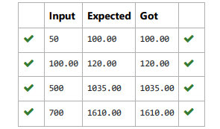

3. Write a program that returns the second last digit of the given number. Second last digit is being referred 10the digit in the tens place in

the given number.

For example, if the given number is 197, the second last digit is 9.

Note1 - The second last digit should be returned as a positive number. i.e. if the given number is -197, the second last digit is 9.

Note2 - If the given number is a single digit number, then the second last digit does not exist. In such cases, the program should return -1.

i.e. if the given number is 5, the second last digit should be returned as -1

**PROGRAM:**

n=int(input())

if(n>0 and n<10):

print(-1)

else:

n=abs(n)

n=(n//10)%10

print(n)

**OUTPUT:**

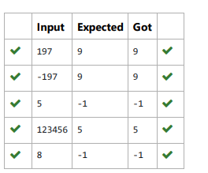

4. The length of a month varies from 28 to 31 days. In this exercise you will create a program that reads the name of a month from the user as

a string. Then your program should display the number of days in that month. Display “28 or 29 days” for February so that leap years are

addressed.

Sample Input 1

February

Sample Output 1

February has 28 or 29 days in it.

Sample Input 2

March

Sample Output 2

March has 31 days in it.

Sample Input 3

April

Sample Output 3

April has 30 days in it.

**PROGRAM:**

m=str(input())

if(m=="January"):

print("January has 31 days in it.")

elif(m=="February"):

print("February has 28 or 29 days in it.")

elif(m=="March"):

print("March has 31 days in it.")

elif(m=="April"):

print("April has 30 days in it.")

elif(m=="May"):

print("May has 31 days in it.")

elif(m== "June"):

print("June has 30 days in it.")

elif(m=="July"):

print("July has 31 days in it.")

elif(m=="August"):

print("August has 30 days in it.")

elif(m=="September"):

print("September has 31 days in it.")

elif(m=="October"):

print("October has 30 days in it.")

elif(m=="November"):

print("November has 31 days in it.")

else:

print("December has 30 days in it")

**OUTPUT:**

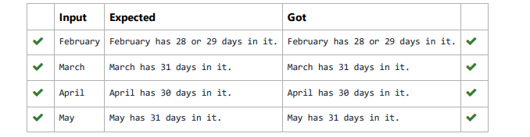

5. The Chinese zodiac assigns animals to years in a 12 year cycle. One 12 year cycle is shown in the table below. The pattern repeats from

there, with 2012 being another year of the dragon, and 1999 being another year of the hare.

Year Animal

2000 Dragon

2001 Snake

2002 Horse

2003 Sheep

2004 Monkey

2005 Rooster

2006 Dog

2007 Pig

2008 Rat

2009 Ox

2010 Tiger

2011 Hare

Write a program that reads a year from the user and displays the animal associated with that year. Your program should work correctly for

any year greater than or equal to zero, not just the ones listed in the table.

Sample Input 1

2010

Sample Output 1

2010 is the year of the Tiger.

Sample Input 2

2020

Sample Output 2

2020 is the year of the Rat.

**PROGRAM:**

x=int(input())

n=x%12

if(n==8):

print(x,"is the year of the Dragon.")

elif(n==9):

print(x,"is the year of the Snake.")

elif(n==10):

print(x,"is the year of the Horse.")

elif(n==11):

print(x,"is the year of the Sheep.")

elif(n==0):

print(x,"is the year of the Monkey.")

elif(n==1):

print(x,"is the year of the Rooster.")

elif(n==2):

print(x,"is the year of the Dog.")

elif(n==3):

print(x,"is the year of the Pig.")

elif(n==4):

print(x,"is the year of the Rat.")

elif(n==5):

print(x,"is the year of the Ox.")

elif(n==6):

print(x,"is the year of the Tiger.")

else:

print(x,"is the year of the Hare.")

**OUTPUT:**

